NAMA : Damping Rizki W.A

NIM : L200180213

Kelas H / Praktikum Sistem Basis Data

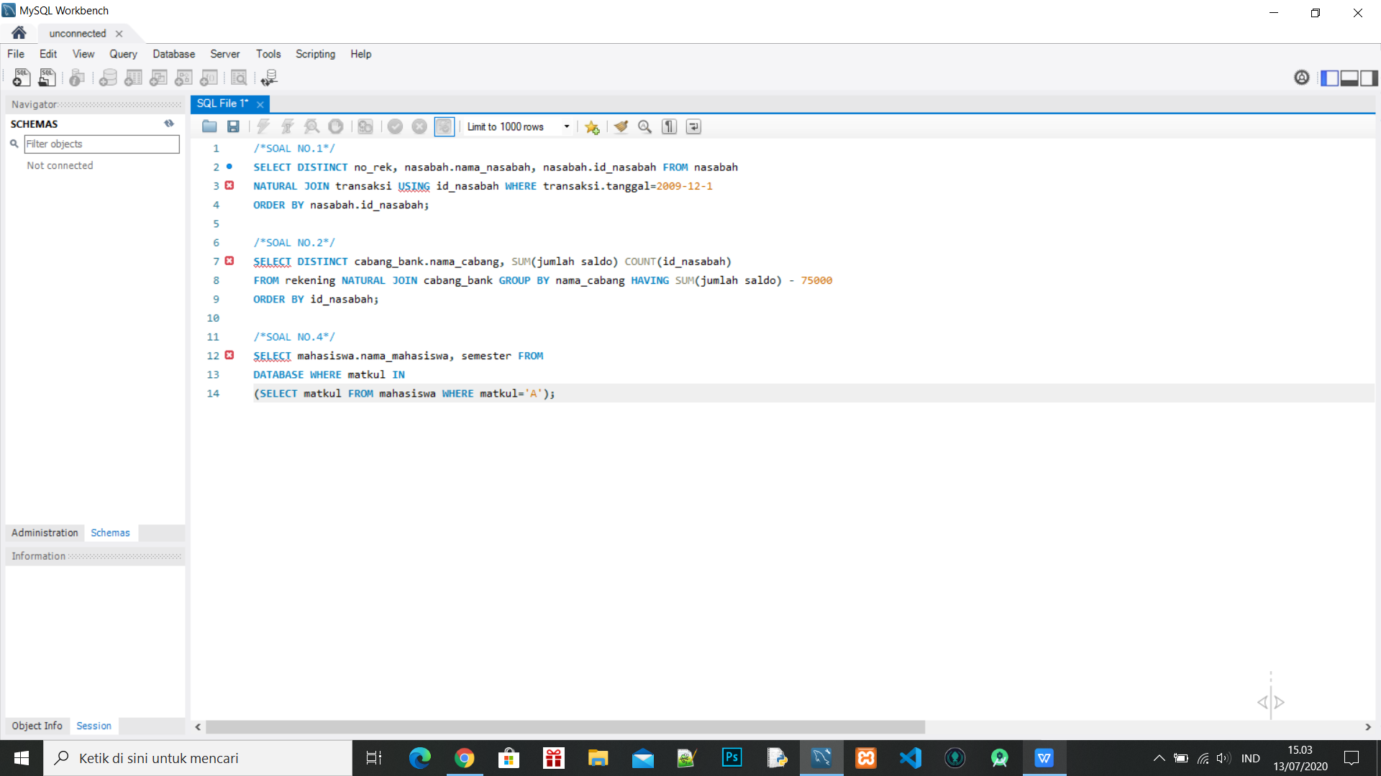

# Jawaban No.3

CREATE USER ‘213’@’localhost’ IDENTIFIED BY ‘password’;

GRANT ALL PRIVILEGES ON * . * TO ‘213’@’localhost’;

FLUSH PRIVILEGES;

CREATE TABLE Coba

( id INT,

nama VARCHAR(120)

);

INSERT INTO Coba(id,nama) VALUES(1, ‘saya’);

UPDATE Coba SET nama=’siapa’ WHERE id=1

DELETE FROM Coba WHERE nama=’saya’;